LAB REPORT

for
Lab Assignment #2:
Black Box investigation

Table of Contents

1. Introduction…………………………………………………………………………..1

2. Functional Behavioral Requirements……………….……………………………..1

3. Testing Plan...………………………………………………………………………..1

3.1. Pre-Prototype Testing Plan………….………………………………….………..1

3.2. Prototype Construction Plan …………….………….…………..……...………..2

3.3. Simulation Testing Plan………...……………………………………….………..3

3.4. Prototype Testing Plan………….……………………………………….………..3

4. Answers to Question………………………………………….……………………..4

5. Result of testing…….………………………………………….……………………..5

5.1. Prototype Testing Results………………………………….……………………..5

6. Conclusion………….……………………………………………………….………..8

1. Introduction
“In this assignment, students will come up with a procedure to reverse-engineer a given black-box combinational circuit. This is a problem that frequently arises in industry, e.g., when taking apart and analyzing a pre-existing legacy system for which the original documentation has been lost or is unavailable, to figure out what it’s doing, so that the same function can be re-implemented in a newer technology.”
-- quoted from Lab Assignment #2 document.

2. Functional Behavioral Requirements
Unknown.

3. Testing Plan
In this section, the planning, design computer simulation experiments, and prototype testing experiments that will be carried to test the design is as follows.

3.1. Pre-Prototype Testing Plan
The functionality requirements of the given circuit are a mystery, so it will be tested. The procedure that I will go through to test the functionality of the unknown circuit is a simple yet scrupulous process. The user interface of the DE2 board consists of the first four slider switches (SW0-SW3) to control the first four red LEDs (LEDR0-LEDR3).

Steps
- Step 1: Turn on the DE2 board.
- Step 2: Run every possible switch combination using the four first switches (table 1).
- Step 3: Record outcome/data.
Table 1
SW0 | SW1 | SW2 | SW3 | LEDR0 | LEDR1 | LEDR2 | LEDR3 | LEDR4
U | U | U | U
D | D | D | D
U | U | U | D
U | U | D | U
U | D | U | U
D | U | U | U
U | U | D | D
U | D | D | U
D | D | U | U
U | D | U | D
D | U | U | D
D | U | D | U
U | D | D | D
D | D | D | U
D | U | D | D
D | D | U | D

The above table summarizes the different tests/combinations

3.2. Prototype Construction Plan
In this section, I will describe in detail how I will put together my prototype in lab. This includes the procedure for collecting and analyzing the data from the mystery circuit.

Once I have collected all of the date, the systematic method that I will use to analyze the data would be to make a truth table. The truth table will be filled using the results of the LED’s being unlit or lit and the Switches being up (U) or down (D). Then I would take the truth table and construct a Karnaugh map. This technique will help produce a re-implemented design and function as the preprogrammed circuit.

Using the truth table and Karnaugh map, producing a design that uses the smallest number of basic 1- and 2-input gates shouldn’t be a difficult task. My analytical plan is to determine the correct operators/logic to display the correct output of the LED’s.

 | X1 X2
X3 | 00 | 01 | 11 | 10
0
1

Table 2. Role and device assignments for the prototype design.
Role | Device Type | Device ID
input | Switch | SW0
input | Switch | SW1
input | Switch | SW2
input | Switch | SW3
output | LED | LEDR0
output | LED | LEDR1
output | LED | LEDR2
output | LED | LEDR3

Once the logic is worked out, the program file will then be downloaded to DE2 board. At
this point the prototype construction will be complete, and the prototype is ready for
simulation.

3.3. Simulation Testing Plan
In this section, I will describe the step-by-step process for testing the controller system of the re-designed circuit electronically under Quartus.

Steps:
1. Save the schematic as a file, and create a new project with it.
2. Use the Simulator tool to create a new waveform file.
3. Add the necessary inputs.
4. To run through all the signal combinations, create a Count.
5. Save the waveform. Select Functional simulation, and generate the functional
simulation netlist.
6. View the report.

3.4. Prototype Testing Plan
Now that the re-implemented design is made, the prototyping testing can begin. They same steps that were used in the pre-prototype testing plan will be used again.

Steps
- Step 1: Turn on the DE2 board.
- Step 2: Run every possible switch combination using the four first switches (table 1).
- Step 3: Record outcome/data.

4. Answers to Questions
Question 1.
The procedure that I will go through to test the functionality of the unknown circuit is a simple yet scrupulous process. The user interface of the DE2 board consists of the first four slider switches (SW0-SW3) to control the the first four red LEDs (LEDR0-LEDR3).

- Step 1: Turn on the DE2 board.
- Step 2: Run every possible switch combination using the four first switches.
- Step 3: Record outcome/data.

SW0 | SW1 | SW2 | SW3 | LEDR0 | LEDR1 | LEDR2 | LEDR3
0 | 0 | 0 | 0
0 | 0 | 0 | 1
0 | 0 | 1 | 0
0 | 0 | 1 | 1
0 | 1 | 0 | 0
0 | 1 | 0 | 1
0 | 1 | 1 | 0
0 | 1 | 1 | 1
1 | 0 | 0 | 0
1 | 0 | 0 | 1
1 | 0 | 1 | 0
1 | 0 | 1 | 1
1 | 1 | 0 | 0
1 | 1 | 0 | 1
1 | 1 | 1 | 0
1 | 1 | 1 | 1

Question 2.
Once I have collected all of the date, the systematic method that I will use to analyze the data would be to make a truth table. The truth table will be filled using the results of the LED’s being unlit or lit and the Switches being up (U) or down (D). Then I would take the truth table and construct a Karnaugh map. This technique will help produce a re-implemented design and function as the preprogrammed circuit.
Using the truth table and Karnaugh map, producing a design that uses the smallest number of basic 1- and 2-input gates shouldn’t be a difficult task. My analytical plan is to determine the correct operators/logic to display the correct output of the LED’s.

Question 3.
Example Truth Table
Inputs |  |  | Outputs
X1 | X2 | X3 | K1 | K2 | K3
0 | 0 | 0 | 0 | 1 | 0
0 | 0 | 1 | 0 | 1 | 1
0 | 1 | 0 | 1 | 1 | 1
0 | 1 | 1 | 0 | 0 | 1
1 | 0 | 0 | 0 | 1 | 0
1 | 0 | 1 | 0 | 0 | 1
1 | 1 | 0 | 1 | 0 | 0
1 | 1 | 1 | 1 | 1 | 0

K1
 | X1 X2
X3 | 00 | 01 | 11 | 10
0 | 0 | 1 | 1 | 0
1 | 0 | 0 | 1 | 0

K2
 | X1 X2
X3 | 00 | 01 | 11 | 10
0 | 1 | 1 | 0 | 1
1 | 1 | 0 | 1 | 0

K3
 | X1 X2
X3 | 00 | 01 | 11 | 10
0 | 0 | 1 | 0 | 0
1 | 1 | 1 | 0 | 1

As an example to my analysis method, I made a random 3-input, 3-output Boolean function.

5. Results of Testing
This section presents the results of testing.

5.1. Prototype Testing Results
SW0 | SW1 | SW2 | SW3 | LEDR0 | LEDR1 | LEDR2 | LEDR3
0 | 0 | 0 | 0 | 1 | 1 | 1 | 0
0 | 0 | 0 | 1 | 1 | 1 | 1 | 1
0 | 0 | 1 | 0 | 0 | 0 | 0 | 1
0 | 0 | 1 | 1 | 1 | 1 | 0 | 0
0 | 1 | 0 | 0 | 0 | 0 | 1 | 1
0 | 1 | 0 | 1 | 1 | 1 | 0 | 1
0 | 1 | 1 | 0 | 1 | 0 | 1 | 1
0 | 1 | 1 | 1 | 1 | 1 | 1 | 0
1 | 0 | 0 | 0 | 1 | 1 | 0 | 1
1 | 0 | 0 | 1 | 1 | 0 | 1 | 1
1 | 0 | 1 | 0 | 1 | 1 | 1 | 0
1 | 0 | 1 | 1 | 1 | 1 | 1 | 1
1 | 1 | 0 | 0 | 0 | 0 | 0 | 1
1 | 1 | 0 | 1 | 1 | 0 | 0 | 1
1 | 1 | 1 | 0 | 0 | 1 | 0 | 0
1 | 1 | 1 | 1 | 0 | 0 | 1 | 1
The above truth table summarizes the different combinations of the 4 switches used, followed by the output of LED’s.

LEDR0
 | SW0 SW1
SW2  SW3 | 00 | 01 | 11 | 10
00 | 1 | 0 | 0 | 1
01 | 1 | 0 | 1 | 1
11 | 0 | 1 | 0 | 1
10 | 1 | 1 | 0 | 1
LEDR1
 | SW0 SW1
SW2  SW3 | 00 | 01 | 11 | 10
00 | 1 | 0 | 0 | 1
01 | 1 | 1 | 0 | 0
11 | 1 | 1 | 0 | 1
10 | 0 | 0 | 1 | 1

LEDR2
 | SW0 SW1
SW2  SW3 | 00 | 01 | 11 | 10
00 | 1 | 1 | 0 | 0
01 | 1 | 0 | 0 | 1
11 | 0 | 1 | 1 | 1
10 | 0 | 1 | 0 | 1
LEDR3
 | SW0 SW1
SW2  SW3 | 00 | 01 | 11 | 10
00 | 0 | 1 | 1 | 1
01 | 1 | 1 | 1 | 1
11 | 0 | 0 | 1 | 1
10 | 1 | 1 | 0 | 0

LED | FUNCTION
LEDR0 | !SW0 SW2 SW3 + !SW0 SW1 SW2 + SW0 !SW1 + !SW1 !SW2 + SW0 !SW2 SW3
LEDR1 | !SW0 SW3 + !SW1 SW2 SW3 + !SW1 !SW2 !SW3 + SW0 SW1 !SW3
LEDR2 | !SW0 !SW1 !SW2 + !SW1 !SW2 SW3 + !SW0 SW1 !SW3 + SW1 SW2 SW3 + SW0 !SW1 SW2
LEDR3 | !SW2 SW3 + !SW0 SW2 !SW3 + !SW0 SW1 !SW3 + SW0 !SW2 + SW0 SW3

The Karnaugh maps above help evaluate the functions above. With the use of these functions, a logic circuit was then created in Quartus. The circuit is displayed below.
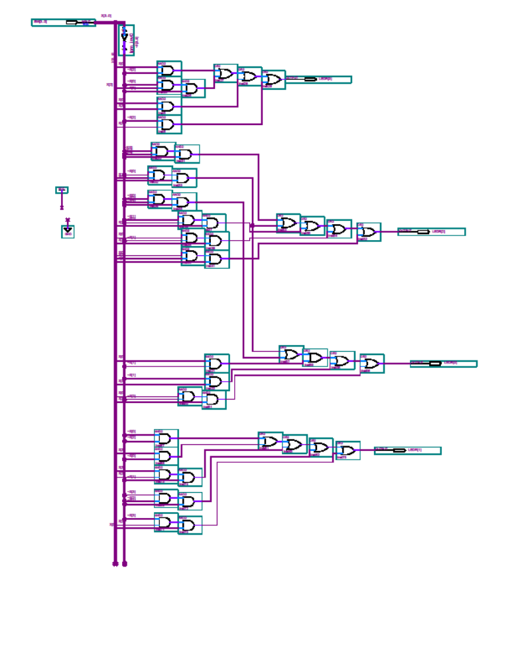

6. Conclusion
We began this lab with an unknown preprogrammed circuit. After the use of a prepared testing plan and analysis, we re-implemented the functions into an in lab constructed circuit using Quartus2. It is only reluctant that the chip only uses four switches and four LED’s.
In the lab, after completing and compiling the re-implemented circuit, there were a few problems. None of the LED’s lit up at all. My partner and I first thought the problem was that we used 3-6 input gates (the instructions called for no greater than 2-input). After much thought and correction, we realized that the assignment editor was not installed for the circuit. Also, the logic was LEDR3 had to be redone, and there was a naming error for LEDR1 that was fixed. After all these problems were resolved, the board preformed the logic just as given.
In this lab assignment, we learned a few important lessons and utilized a few new concepts. Logic minimization is of key significance in efficiency of a circuit, and with the use of K-maps this goal was achieved. Thus, this assignment aided in the understanding of this tool. This assignment also helps in the ability to design and carry out experimental procedures suitable for reverse-engineering the design of a simple combinational logic circuit.

